**Installation guide for Local Crypto Server**

Food-Chain Crypto is a locally hosted server written in Java programming language. This program is meant to be hosted locally (WIFI) at every location of the food chain. It listens to requests from Food-Chain Scanner mobile application and sends encrypted response back.

**Requirements:**

* Java 8 - http://www.oracle.com/technetwork/java/javase/downloads/jdk8-downloads-2133151.html
* NetBeans IDE - https://netbeans.org/downloads/

**Step 1: Install/Use latest NetBeans IDE**

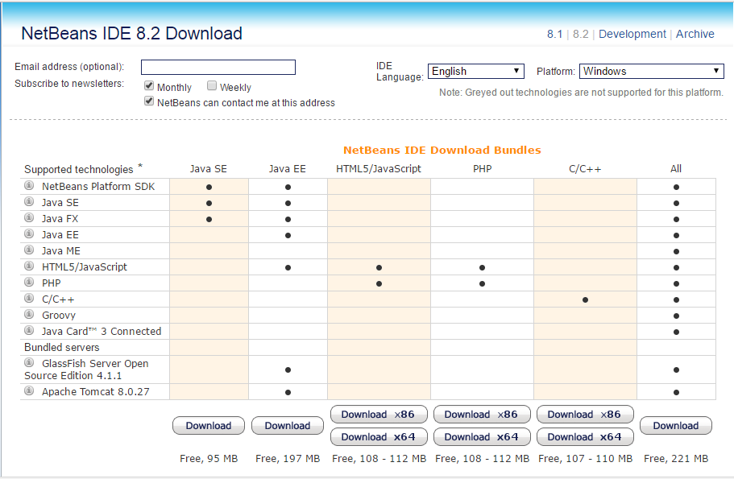

Download NetBeans IDE with Java SE or All. Download link is provided at the requirements section above.

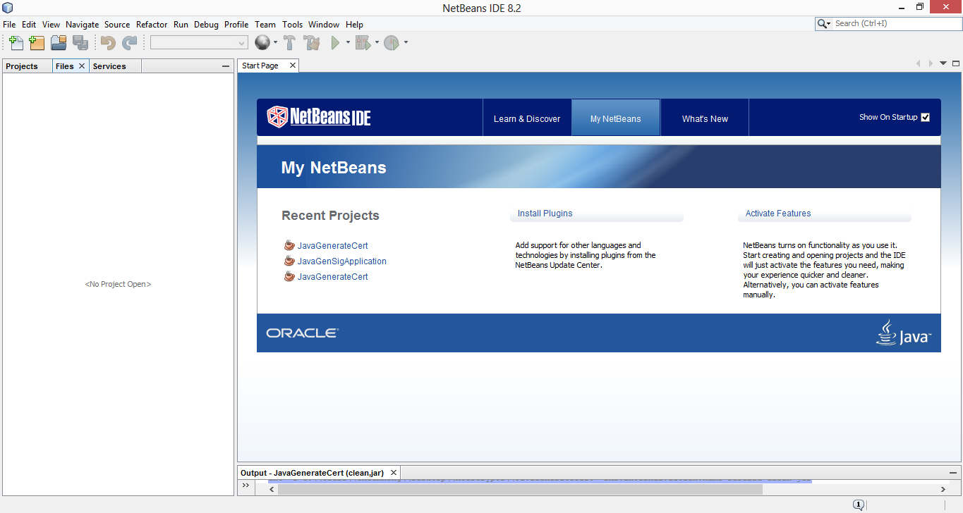

Open the NetBeans IDE 8.2.

**Step 2: Open the project file (Food-Chain Crypto)**

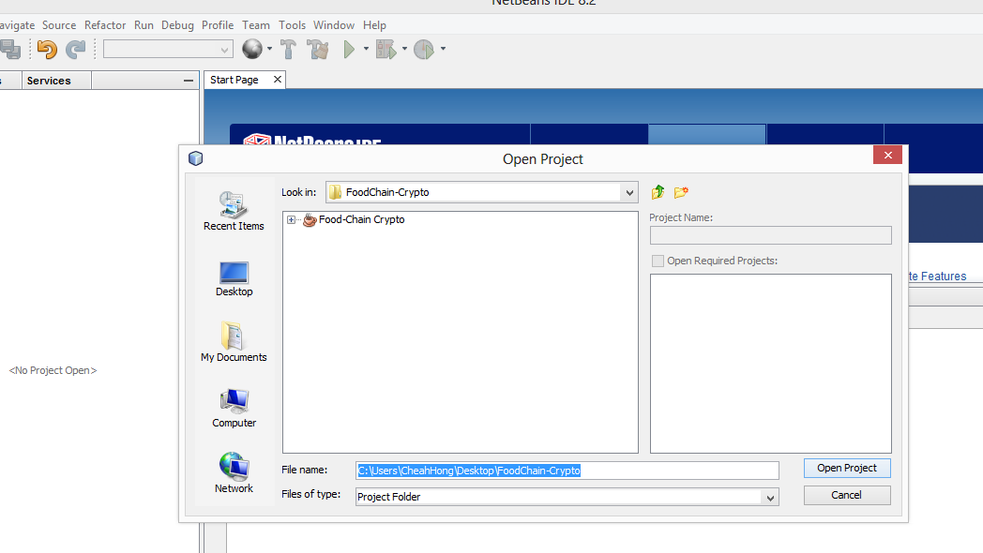

Find the project path and open the project.

**Step 3: Customizing current location**

For demo purposes, currently there are three location folders available in the project file, namely Btu, Kch and Mri (Bintulu, Kuching, Miri ), which are the cities of Sarawak, Malaysia.

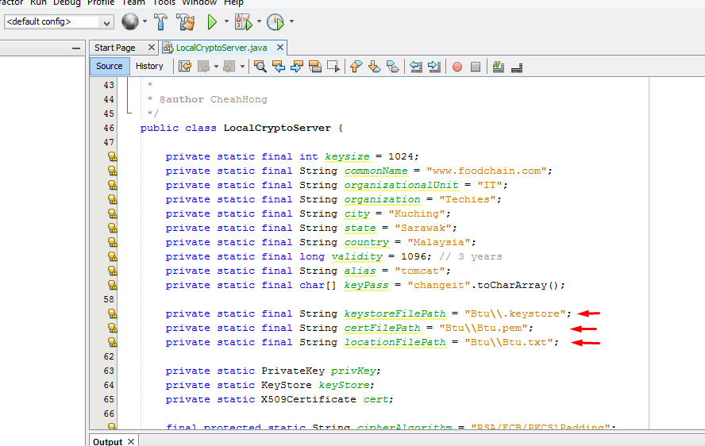

To change between locations, simply go to the LocalCryptoServer.java and change the string paths as shown in the diagram above. For instance, change the string “Kch\\Kch.pem” to “Btu\\Btu.pem” or “Mri\\Mri.pem”;

**Step 4: Run the project**

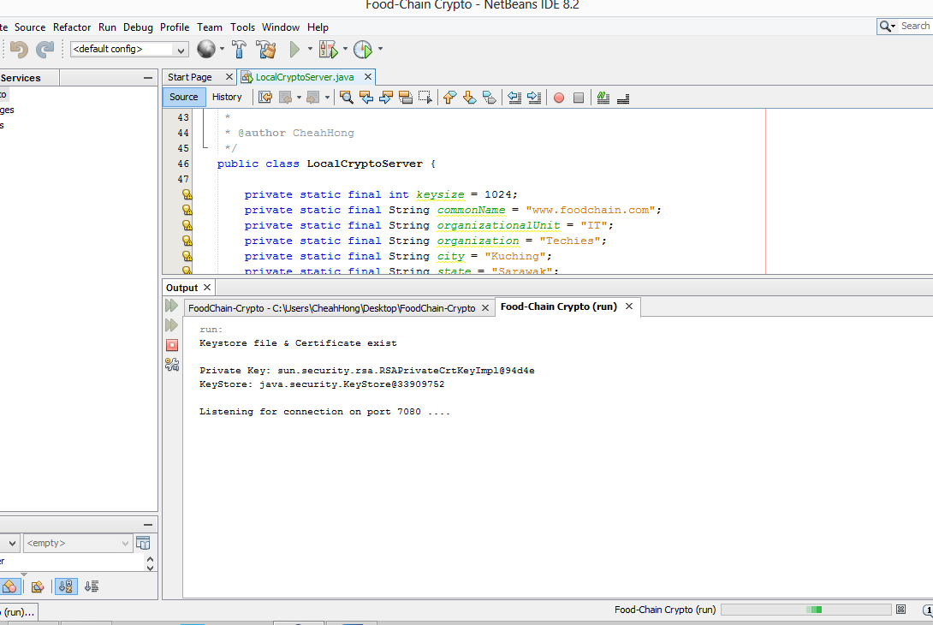

The program is now ready to receive requests from Food-Chain Scanner App.